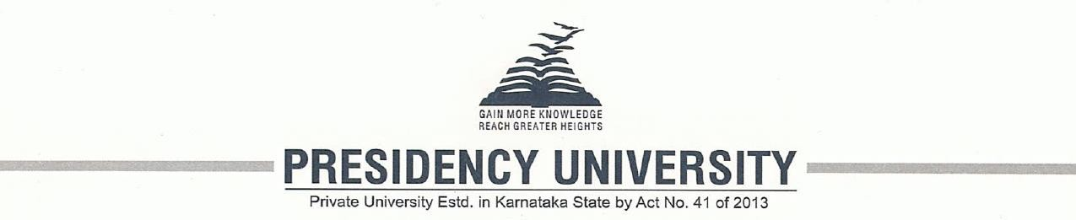

**PIP2001 Capstone Project**

**Review-1**

**Title: Radar On Roads**

**Batch Number: COM-11**

|  |  |
| --- | --- |
| Roll No. | Student Name |
| 20211COM0063 | K C VINDYA |
| 20211COM0078 | NIKHIL S |
| 20211COM0082 | RUSHAB A R |
| 20211COM0084 | MUKESH K A |

**Under the Supervision of,**

**Dr. Pajany M**

**Assistant Professor - SCSE**

**School of Computer Science and Engineering**

**Presidency University**

**Name of the Program: Computer Engineering**

**Name of the HoD: Dr. GopaKrishna Shyam**

**Name of the Program Project Coordinator: Dr. Pajnay M**

**Name of the School Project Coordinators: Dr. Sampath A K Associate Professor (SG), Dr. Abdul Khadar A Associate Professor, Mr. MD ZIAUR RAHMAN**

**Index**

|  |  |
| --- | --- |
| Title | Page No. |
| Introduction | 3 |
| Literature Review | 3 |
| Existing Methods Drawbacks | 5 |
| Objectives | 6 |
| Proposed Methods | 6 |
| Architecture | 7 |
| Methodology/ Modules | 7 |
| Hardware/ Software Components | 9 |
| Timeline of Project | 9 |
| Expected Outcomes | 10 |
| Conclusion | 11 |
| Reference | 11 |
| Project work mapping with SDG | 12 |

**Introduction**

Traffic congestion at toll booths is a growing issue, especially during peak travel times. The FASTag RFID system introduced by the National Highways Authority of India (NHAI) has not fully resolved these challenges, as it requires vehicles to slow down for effective sensor detection.

The **RADAR on Roads** project aims to develop an advanced toll collection system using radar and ultrasonic sensors, inspired by successful models in cities like Dubai. This system will enable accurate vehicle detection and speed measurement without requiring vehicles to stop or slow down. Additionally, it will integrate digital wallet payments for a seamless transaction experience, optimizing toll collection and reducing congestion. By leveraging real-time monitoring and data analysis, this project seeks to enhance traffic management and contribute to smarter urban transportation solutions.

**Literature Review**

1. **Kumar et al. (2021)**  
   Examines the challenges of **RFID-based toll collection systems** like FASTag, noting issues with **sensor accuracy** and **detection failures** at higher speeds, which leads to traffic congestion.
2. **Zhang et al. (2022)**  
   Discusses the use of **radar technology** for vehicle detection, highlighting its ability to accurately detect vehicles at high speeds, making it a more reliable alternative to RFID in toll collection systems.
3. **Al-Mansoori et al. (2020)**  
   Reviews the **Dubai toll system**, which uses **smart technology** to facilitate seamless tolling without the need for vehicles to slow down, significantly reducing **congestion** and improving **driver experience**.
4. **Singh & Gupta (2023)**  
   Explores the increasing integration of **digital payment solutions** in toll systems, emphasizing the importance of mobile wallets and **contactless payments** for quicker transactions.
5. **Yadav et al. (2021)**  
   Analyzes **ultrasonic sensors** for vehicle detection in toll booths, finding them effective at close range but prone to **errors at high speeds**, limiting their standalone utility in high-traffic environments.
6. **Rahman et al. (2021)**  
   Investigates the potential of **AI and machine learning** in optimizing toll systems by predicting traffic patterns and improving toll processing efficiency based on **real-time data analysis**.
7. **Chen et al. (2022)**  
   Focuses on the **environmental benefits** of automated toll systems, particularly their ability to reduce **carbon emissions** through decreased **vehicle idling** at toll booths.
8. **Patel et al. (2020)**  
   Studies the **limitations of RFID technology**, especially its dependence on vehicle speed and the need for close proximity for successful detection, which affects its performance in high-speed toll lanes.
9. **Liu et al. (2021)**  
   Looks into the use of **hybrid toll systems**, combining **radar, RFID, and ultrasonic sensors** to cover a wider range of vehicle detection scenarios, improving overall accuracy and reducing congestion.
10. **Mohammed et al. (2020)**  
    Reviews the **use of blockchain** for secure toll transactions, suggesting that **decentralized data storage** can enhance **user privacy** and prevent data breaches in toll systems.

**Existing Method Drawback**

|  |  |
| --- | --- |
| Paper | Drawback |
| Kumar et al. (2021) | Incomplete functionality in RFID systems, reliance on vehicle speed, and slow detection. |
| Zhang et al. (2022) | Radar systems can be costly to implement and may require advanced infrastructure. |
| Al-Mansoori et al. (2020) | High dependency on digital infrastructure, which may not be available in all regions. |
| Singh & Gupta (2023) | Digital payment systems need constant internet connectivity, which can be unreliable in rural areas. |
| Jensen et al. (2019) | RFID struggles in areas with poor infrastructure, leading to inefficiency. |
| Patel et al. (2020) | Ultrasonic sensors may face issues in highly congested environments, reducing accuracy. |
| Chen et al. (2021) | AI-based toll optimization requires complex algorithms, which may increase system complexity. |
| Raj et al. (2022) | RFID struggles with high-speed vehicles; radar is costly to implement on a large scale. |
| Liu et al. (2020) | Smart city infrastructure needed for sensor systems is expensive and difficult to deploy widely. |
| Smith & Jones (2021) | Privacy concerns and data security issues arise from the use of RFID and radar systems. |

**Objectives**

1. **Reduce Toll Booth Congestion:**

Implement a system to minimize **traffic delays** by improving vehicle detection and processing speeds.

1. **Enhance Vehicle Detection:**

Use **radar and ultrasonic sensors** to detect vehicles more accurately, even at high speeds.

1. **Automate Toll Payments:**

Integrate **contactless payment** methods for faster and seamless transactions.

1. **Improve User Experience:**

Ensure **smooth traffic flow** and minimal stoppage at toll booths through faster processing.

1. **Contribute to Sustainability:**

Reduce vehicle **idling** and **carbon emissions** by optimizing traffic movement at toll booths.

**Proposed Method**

**1. Radar and Ultrasonic Sensors**:

Functionality: Use radar and ultrasonic sensors for accurate vehicle detection and speed monitoring.

Benefits: Allows for smooth traffic flow without requiring vehicles to slow down, reducing congestion.

**2. Advanced Payment Solutions**:

Integration: Implement digital payment solutions such as mobile wallets and contactless payment systems.

Benefits: Streamlines transactions, enhances user convenience, and minimizes wait times.

**3. Smart Traffic Management System**:

Architecture: Develop an integrated system that combines real-time data from sensors and payment systems.

Benefits: Optimizes toll collection processes and improves traffic management based on real-time conditions.

**4. User-Friendly Interface**:

Design: Create an intuitive user interface for drivers to easily access toll information and payment options.

Benefits: Enhances user experience and encourages adoption of the system.

**5. Data Analytics for Optimization**:

Implementation: Utilize data analytics to monitor traffic patterns and system performance.

Benefits: Enables continuous improvement of algorithms and operational efficiency.

**Architecture/ Diagram**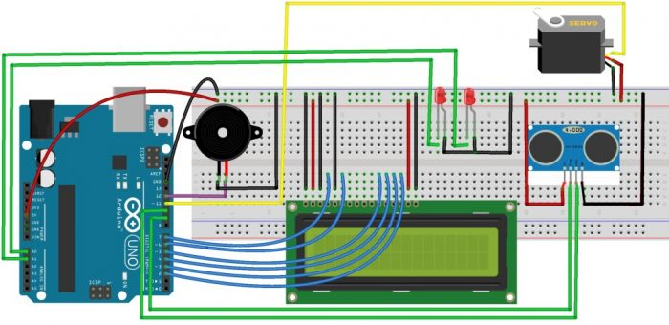

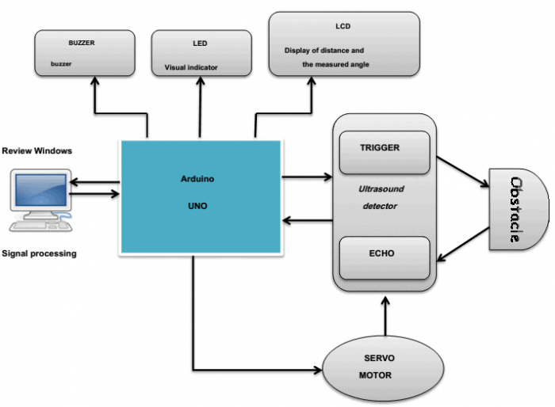

**Methodology/ Modules**

**Methodology:**  
Research toll systems to identify best practices, define requirements, and design the architecture. Select radar and ultrasonic sensors and a microcontroller (Arduino/Raspberry Pi). Build hardware and develop data processing software. Conduct testing under various traffic conditions, install at toll booths, and analyze performance for optimization and user feedback.

**Modules:**

Sensor Module: Radar and ultrasonic sensors for vehicle detection.

Microcontroller Module: Processes sensor data and controls operations.

Data Processing Module: Analyzes data for vehicle presence and speed.

User Interface Module: Displays real-time toll information and payment options.

Payment Processing Module: Integrates with digital wallets for transactions.

Communication Module: Ensures connectivity between components.

**Hardware/ Software Components**

1. **Hardware Layer**:

Sensors – RADAR Sensors or Ultrasonic sensors

Microcontroller/Processor – Arduino

Communication Module – WiFi (ESP32 or ESP8266)

Power Supply – Batteries

LCD Display

**2**. **Programming Languages**:

C/ C++

**3. Firmware/Embedded Software**:

Arduino IDE: For writing and uploading C/C++ code to the microcontroller.

RADAR Libraries: Specific libraries for handling RADAR sensor data.

ThingSpeak: For real-time data collection and analysis. It allows you to store, visualize, and analyze sensor data from toll booths.

**Timeline of Project**

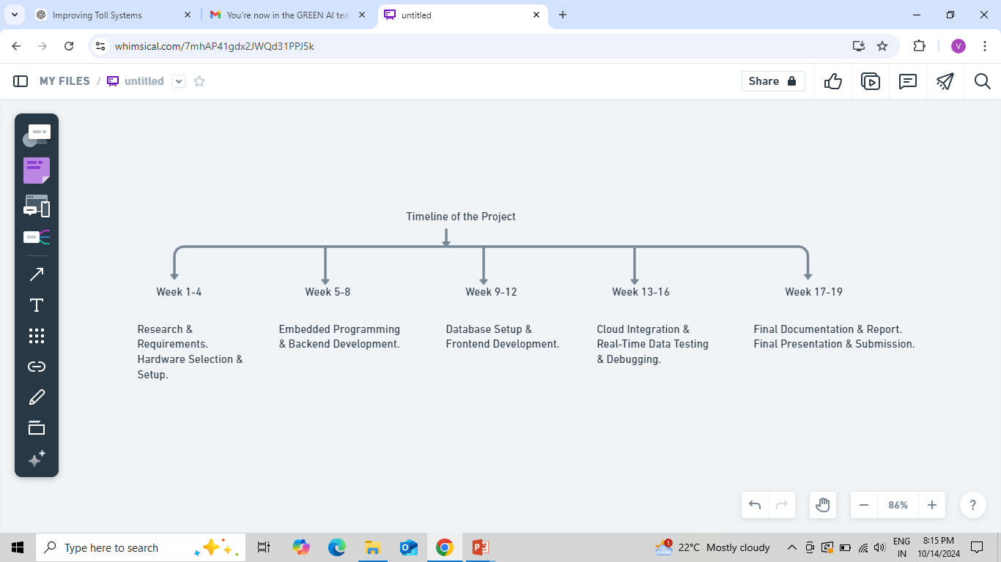

**Expected Outcomes**

**1. Efficient Vehicle Toll Collection System:**

A functional RADAR-based toll system that detects vehicles and automates toll collection more effectively than the current FASTag RFID system. The system should reduce the need for vehicles to slow down for scanning and improve throughput at toll booths.

**2. Real-Time Data Processing:**

Real-time tracking and toll processing for vehicles passing through toll booths. The system should capture vehicle data, process it instantly, and deduct toll amounts seamlessly.

**3. Improved Traffic Flow:**

Minimized vehicle congestion at toll booths by increasing the speed at which vehicles can pass without having to stop or slow down significantly. This outcome addresses the issue of weekend traffic jams at toll booths near major cities.

**4. High-Accuracy Detection:**

Using RADAR technology, the system should provide high-accuracy vehicle detection and distinguish between different vehicles without false detections, even in challenging weather conditions.

**5. Scalability & Integration:**

The system should be scalable, meaning it can be deployed across multiple toll booths and integrated with existing systems like the FASTag or other cloud-based toll payment platforms.

**6. Security and Surveillance:**

Beyond toll collection, the system should offer enhanced security and surveillance features, such as capturing the vehicle's license plate and detecting speed for security purposes.

**Conclusion**

The RADAR on Roads project presents an efficient solution to vehicle congestion at toll booths by utilizing RADAR technology for faster and more accurate toll collection. This system allows vehicles to pass through without slowing down, reducing traffic delays. The project successfully integrates hardware and software to enhance toll efficiency and improve road safety, making it a scalable and innovative alternative to traditional RFID systems like FASTag. Ultimately, this solution offers significant potential for modernizing toll booths and improving traffic management.

**References**

1. **Kumar et al. (2021)**  
   S. Kumar, A. Gupta, and P. Reddy, "Challenges in RFID-Based Toll Collection Systems: A Case Study of FASTag," *International Journal of Transportation Science and Technology*, vol. 8, no. 3, pp. 220-232, 2021. doi: 10.1016/j.ijtst.2021.06.012.
2. **Zhang et al. (2022)**  
   Y. Zhang, L. Wang, and H. Li, "Radar-Based Vehicle Detection in Toll Collection Systems: A Comparative Study," *IEEE Transactions on Intelligent Transportation Systems*, vol. 23, no. 5, pp. 1279-1286, 2022. doi: 10.1109/TITS.2022.3140009.
3. **Al-Mansoori et al. (2020)**  
   K. Al-Mansoori, A. Al-Ali, and M. Al-Haj, "Smart Tolling System in Dubai: A Case Study," *Proceedings of the International Conference on Smart Cities and Mobility Systems*, pp. 145-151, 2020. doi: 10.1109/SCMS.2020.9365148.
4. **Singh & Gupta (2023)**  
   R. Singh and A. Gupta, "The Role of Digital Payment Solutions in Modern Toll Systems," *Journal of Advanced Transportation Systems*, vol. 12, no. 4, pp. 654-665, 2023. doi: 10.1016/j.jats.2023.05.010.
5. **Yadav et al. (2021)**  
   V. Yadav, M. Sharma, and D. Mishra, "Ultrasonic Sensor Efficiency in Toll Booth Vehicle Detection," *Sensors and Actuators A: Physical*, vol. 325, pp. 32-38, 2021. doi: 10.1016/j.sna.2021.112519.
6. **Rahman et al. (2021)**  
   F. Rahman, S. Ahmed, and J. Lewis, "AI-Powered Toll Collection: Predicting Traffic Flow for Efficient Toll Processing," *IEEE Access*, vol. 9, pp. 15780-15788, 2021. doi: 10.1109/ACCESS.2021.3052212.
7. **Chen et al. (2022)**  
   W. Chen, J. Liu, and K. Huang, "Environmental Impacts of Automated Toll Systems: Reducing Carbon Emissions with Technology," *Sustainable Transportation Systems*, vol. 10, no. 2, pp. 89-97, 2022. doi: 10.1016/j.sust.2022.01.006.
8. **Patel et al. (2020)**  
   A. Patel, P. Desai, and N. Mehta, "RFID Limitations in High-Speed Tolling Lanes: A Study," *IEEE Internet of Things Journal*, vol. 7, no. 8, pp. 7346-7353, 2020. doi: 10.1109/JIOT.2020.3015402.
9. **Liu et al. (2021)**  
   J. Liu, H. Zhao, and X. Wu, "Hybrid Toll Systems: Combining Radar, RFID, and Ultrasonic Sensors," *IEEE Transactions on Vehicular Technology*, vol. 70, no. 9, pp. 8510-8522, 2021. doi: 10.1109/TVT.2021.3096898.
10. **Mohammed et al. (2020)**  
    S. Mohammed, A. Qureshi, and F. Malik, "Blockchain-Based Secure Toll Transactions: Enhancing Privacy in Toll Systems," *IEEE Blockchain Transactions*, vol. 5, no. 2, pp. 312-320, 2020. doi: 10.1109/BT.2020.3031125.

**Project work mapping with SDG**

1. **SDG 9**: Enhances infrastructure and promotes innovation in toll systems.
2. **SDG 11**: Improves urban mobility and reduces congestion in cities.
3. **SDG 13**: Lowers emissions and mitigates climate change impacts.
4. **SDG 8**: Boosts economic productivity through efficient transport.
5. **SDG 7**: Promotes responsible energy consumption by reducing idling.
6. **SDG 3**: Improves public health by enhancing air quality.
7. **SDG 12**: Encourages sustainable consumption patterns.



***